Image | 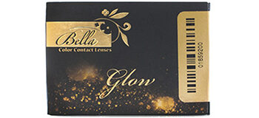
Brand | TIFFANY & CO.
Model Name | BELLA Glow
Price | RS 4300
PRODUCT DETAILS

